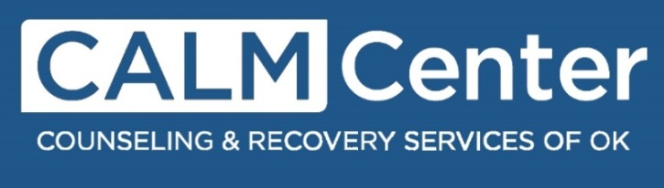

Welcome parent or guardian,

I would like to take this time to briefly inform you of the CALM Center goals and programming so that you will be able to make a clear and informed decision as you move forward.
We are a crisis stabilization unit that seeks to be an alternative to other secure, but more intensive, residential therapy environments. We have a maximum capacity of fifteen, serve males and females 10-17 years of age, typically have a 7-day average length of stay, address a wide range of mental health and substance abuse concerns, and provide the same service regardless of ability to pay. We also only serve those that are voluntarily seeking help or are at least willing to consider our assistance. We do not house children against their will; in our experience, this tends to pollute the therapeutic environment for others who are more openly considering changes. Furthermore, if they are not in immediate danger to themselves or others as demonstrated by an over act, we legally are not able to hold them against their will…even if you as a parent wish them to have treatment.
We operate within a trauma-informed approach, called the Sanctuary Model, and the children we serve will see a therapist and a psychiatrist at least once during the week. It has been our experience that these sessions are most useful when they occur in the latter days of their stay rather than at the beginning. This allows our residents time to settle in, develop a sense of safety, and be more open to therapeutic questions and feedback. If a child asks to speak to a therapist or doctor sooner, we will work to make this happen. We are not focused on using medications to immediately impact symptoms, but our physician will review and make changes or additions to medication routines as needed. They will be asked to attend educational groups held twice daily on the seven commitments of our therapy model, and will be able to have additional individual time with team members if they so desire. We also have other groups that focus on emotional expression through art, grief recovery, and HIV/STD’s education. Furthermore, we have visitation each night and can schedule a family therapy session to address the issues that led to their admission and discuss future treatment recommendations, but will not require this be attended…it is also voluntary.
Our three major goals are as follows:
A pause: Provide children a safe environment to be less impacted by community or family stressors, to hear about and integrate new coping skills, and to talk to experienced staff;
A perspective: Clinical feedback and perceptions from experienced team members, physician, nurses, and therapists regarding client’s mental health, diagnoses, and future needs;
A plan: Assistance in connecting the client and parent/guardian with the next step in treatment.
Lastly, it is our belief that the impact of the CALM Center is not immediate and is not about the latest tricks and tools. We see that the full influence of this safe, supportive environment is realized in the latter stages, and that it is not about one event, group, or person but more about the immersion in a Sanctuary experience. We have faith in our model and have seen many children show improvements in their anxiety, depression, hopefulness, and confidence.
My staff and I look forward to serving your needs. Thank you.
Matthew Crum, MS LPC
CALM Center Director

